SIT-103 DATABSE FUNDAMNETALS

S224001588- JASVEENA

Task 5.1P BASIC SQL

Write a SQL query to retrieve names (displayed as “Employee Name”) and salary of employees. [Relevant table: Works]

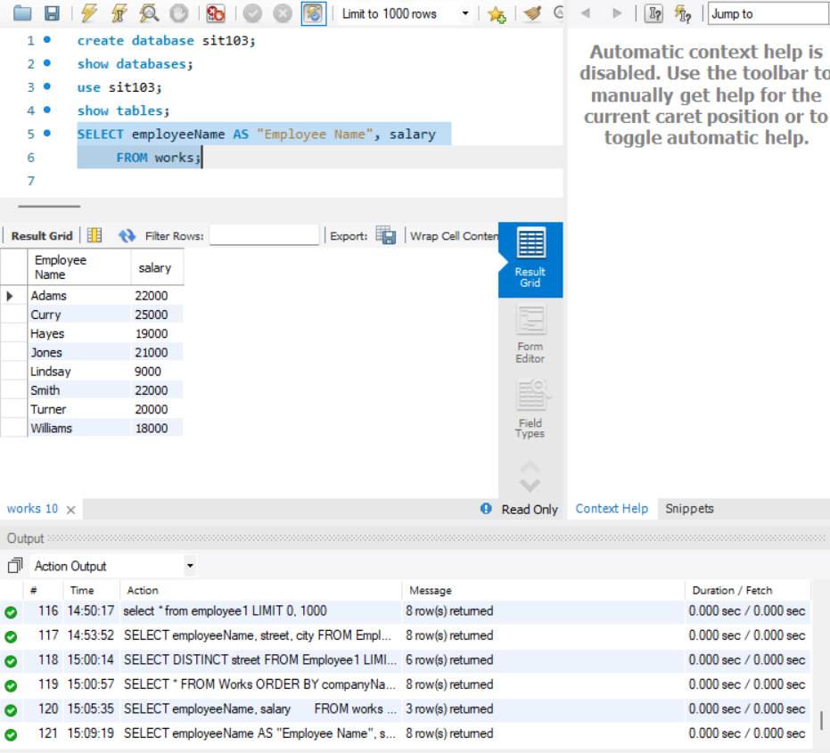

Write a SQL query to list name, street, and city of employees in descending order by their names. [Relevant table: Employee]

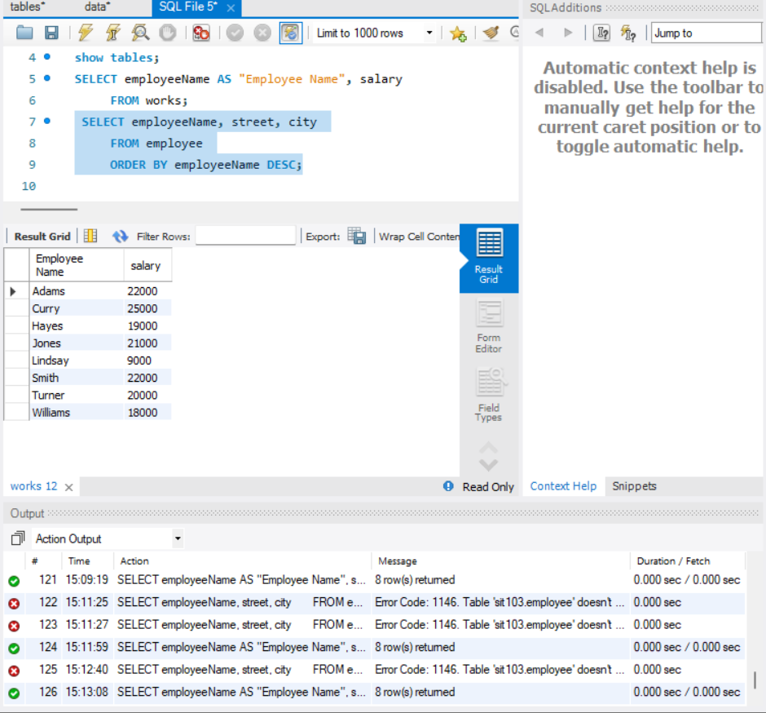

Write a SQL query to get a list of unique streets from the Employee table. [Relevant table: Employee]

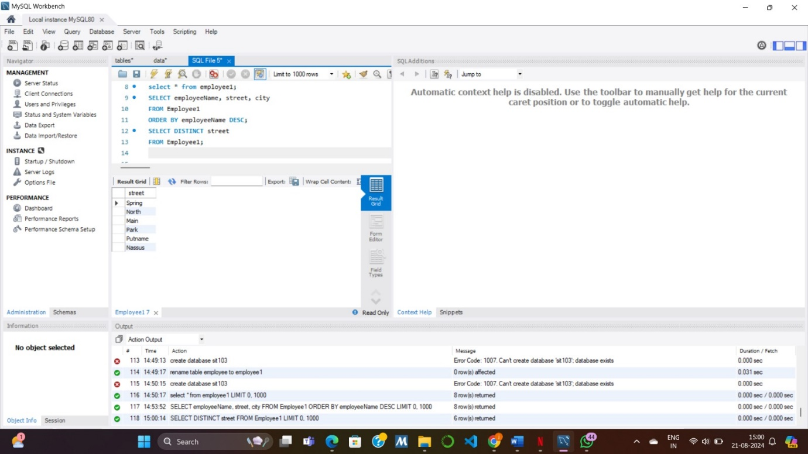

Write a SQL query to list all records in the works table in descending order of company names and within a company in ascending order by employee name. [Relevant table: Works]

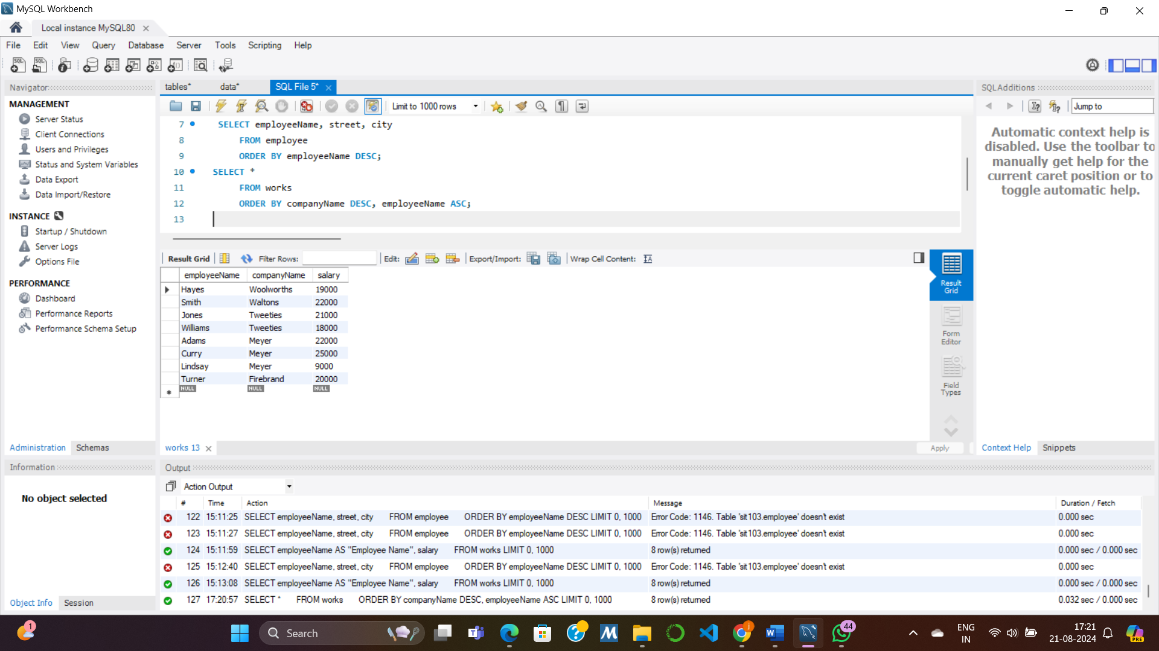

Write a SQL query to list name and salary of all employees who work in Meyer and sort the records in ascending order by their incomes. [Relevant table: Works]

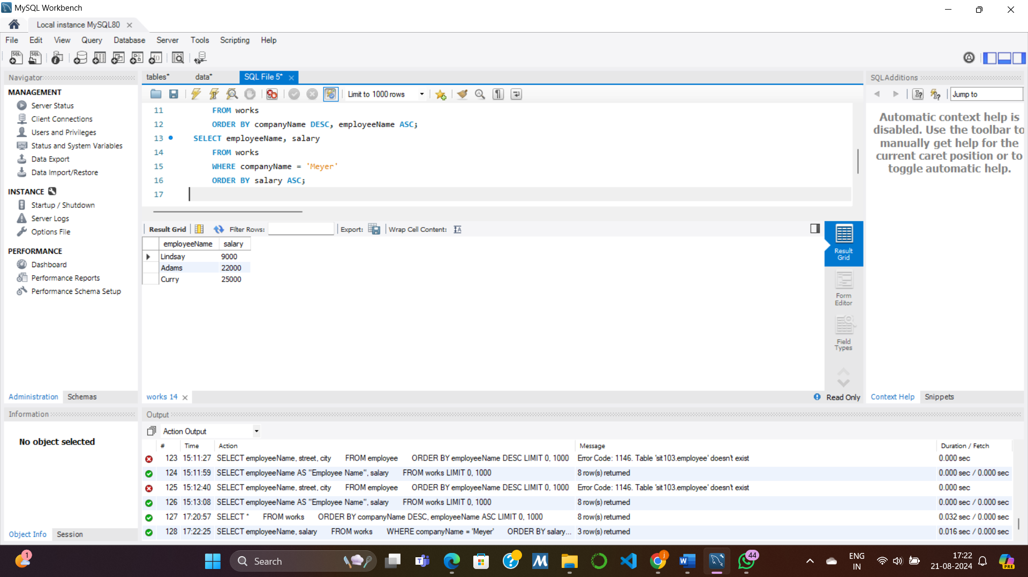

Assuming that the salary in the Works table is annual salary, write a SQL query to retrieve names (displayed as “Employee Name”) and monthly salary as “Monthly Salary” of employees. [Relevant table: Works]

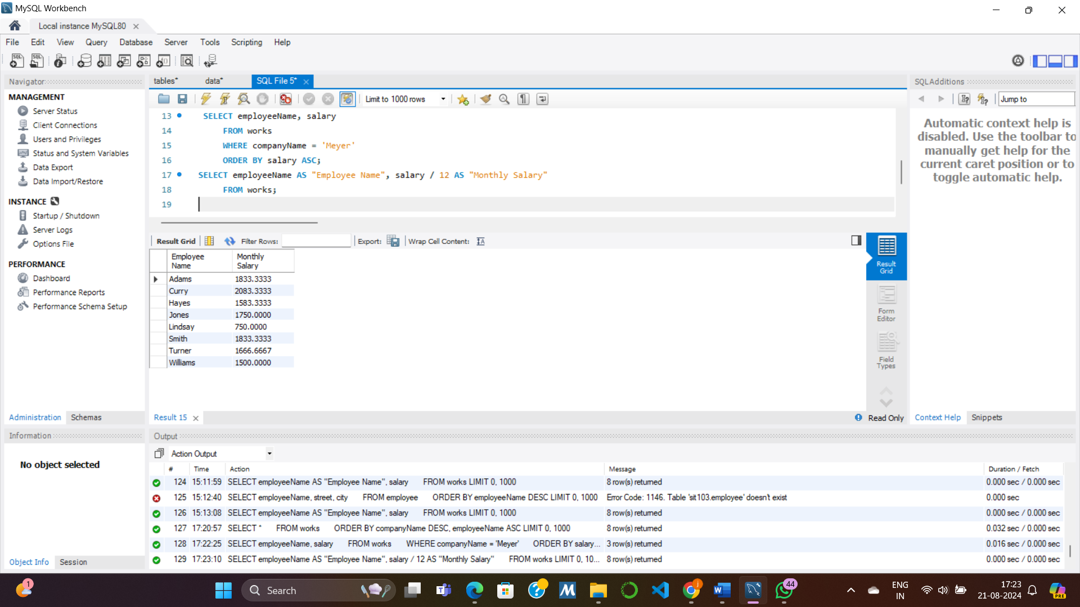

Write a SQL query to list names and salaries of all employees who work in Meyer and earn more than 20000. [Relevant table: Works]

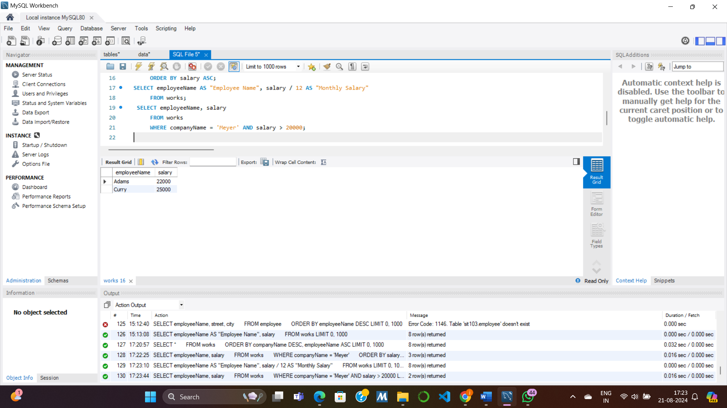

Write a SQL query to list names and companies of the employees who earn in the range of 20000 to 25000 (inclusive). [Relevant table: Works]

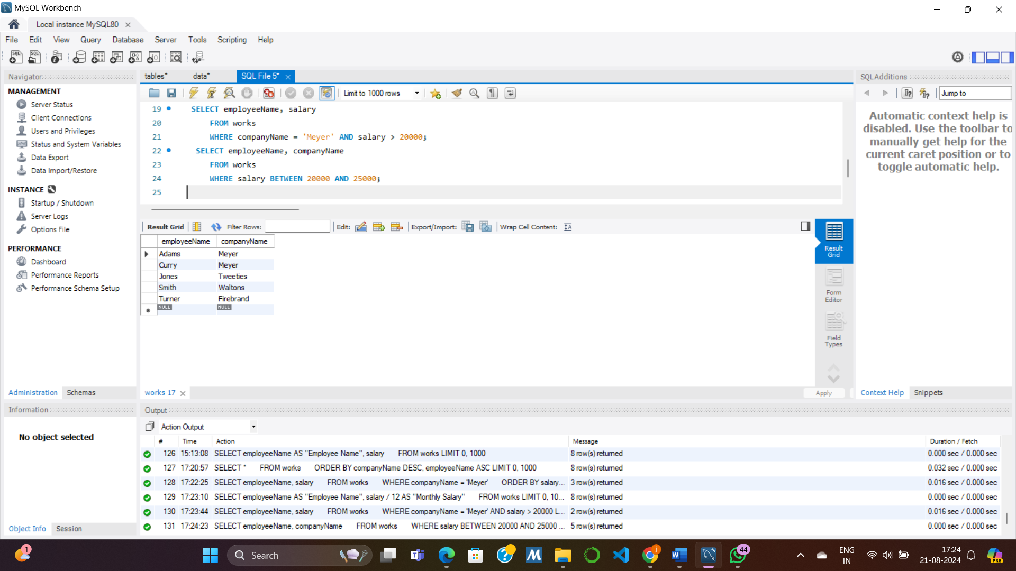

Write a SQL query to list names of employees whose managers have “ll” (double ls) in their names. [Relevant table: Manages]

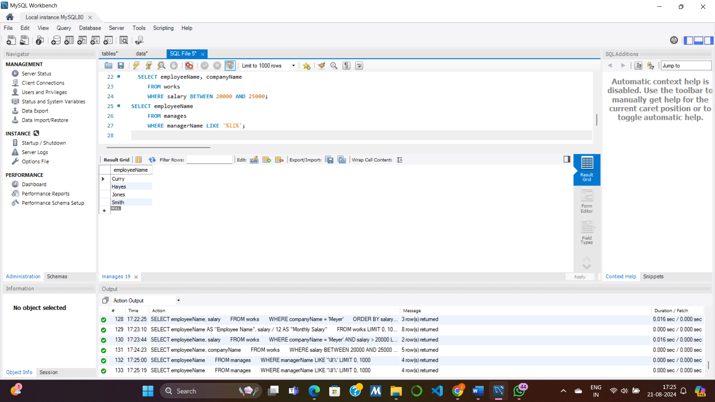

Write a SQL query to list company names and the average salary of their employees. [Relevant table: Works]

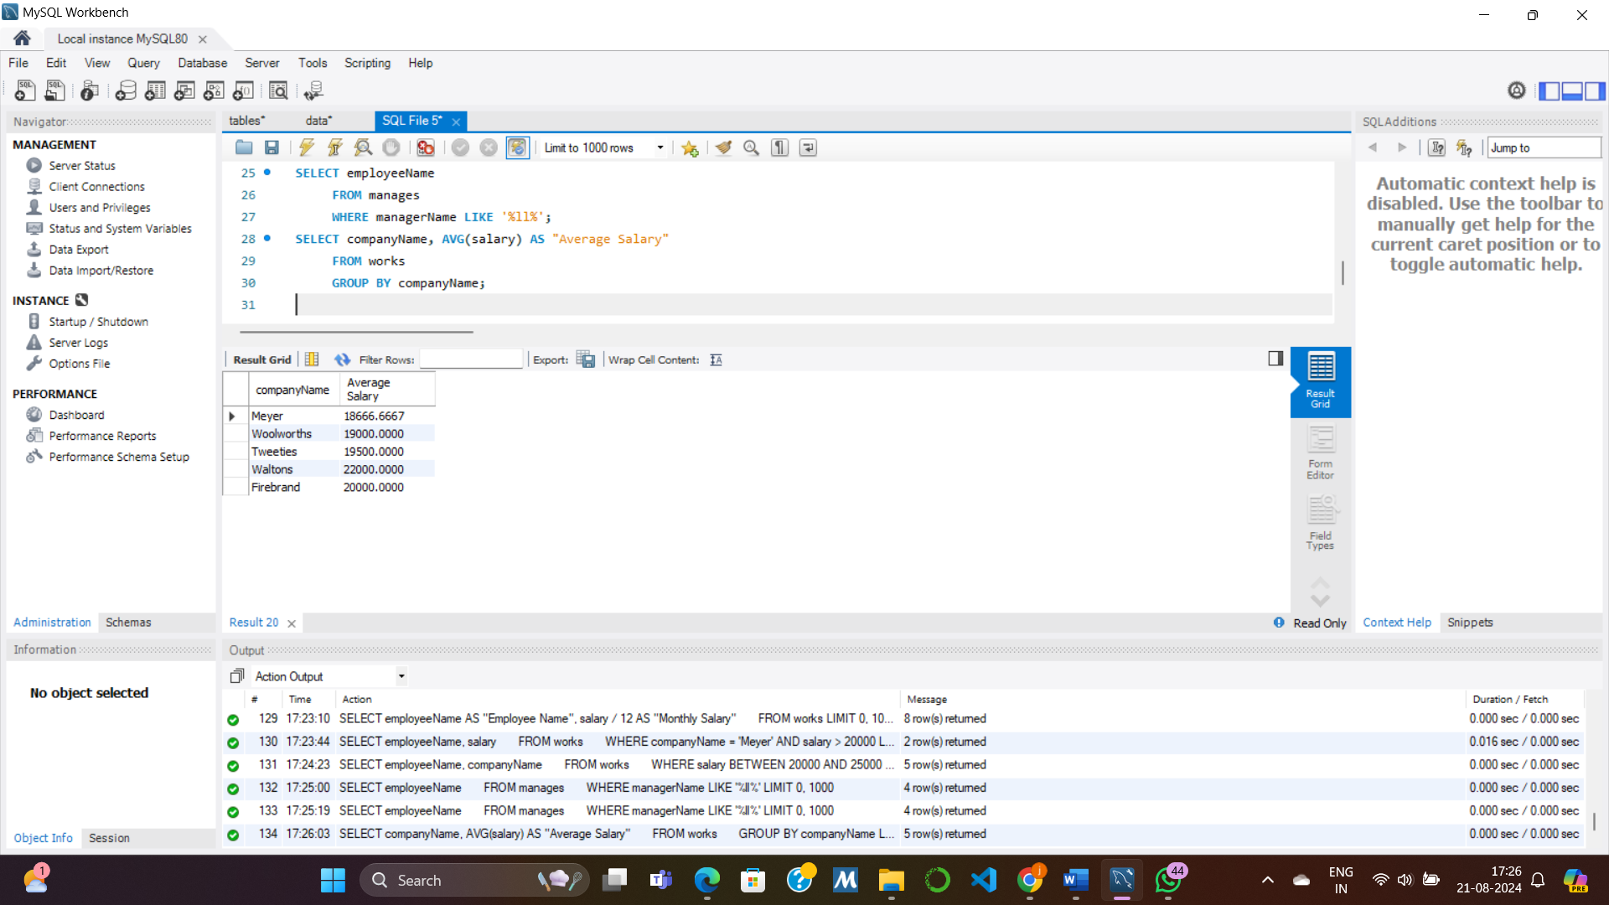

Write a SQL query to list the name of the companies with average salary of employees more than or equal to 20000. [Relevant table: Works]

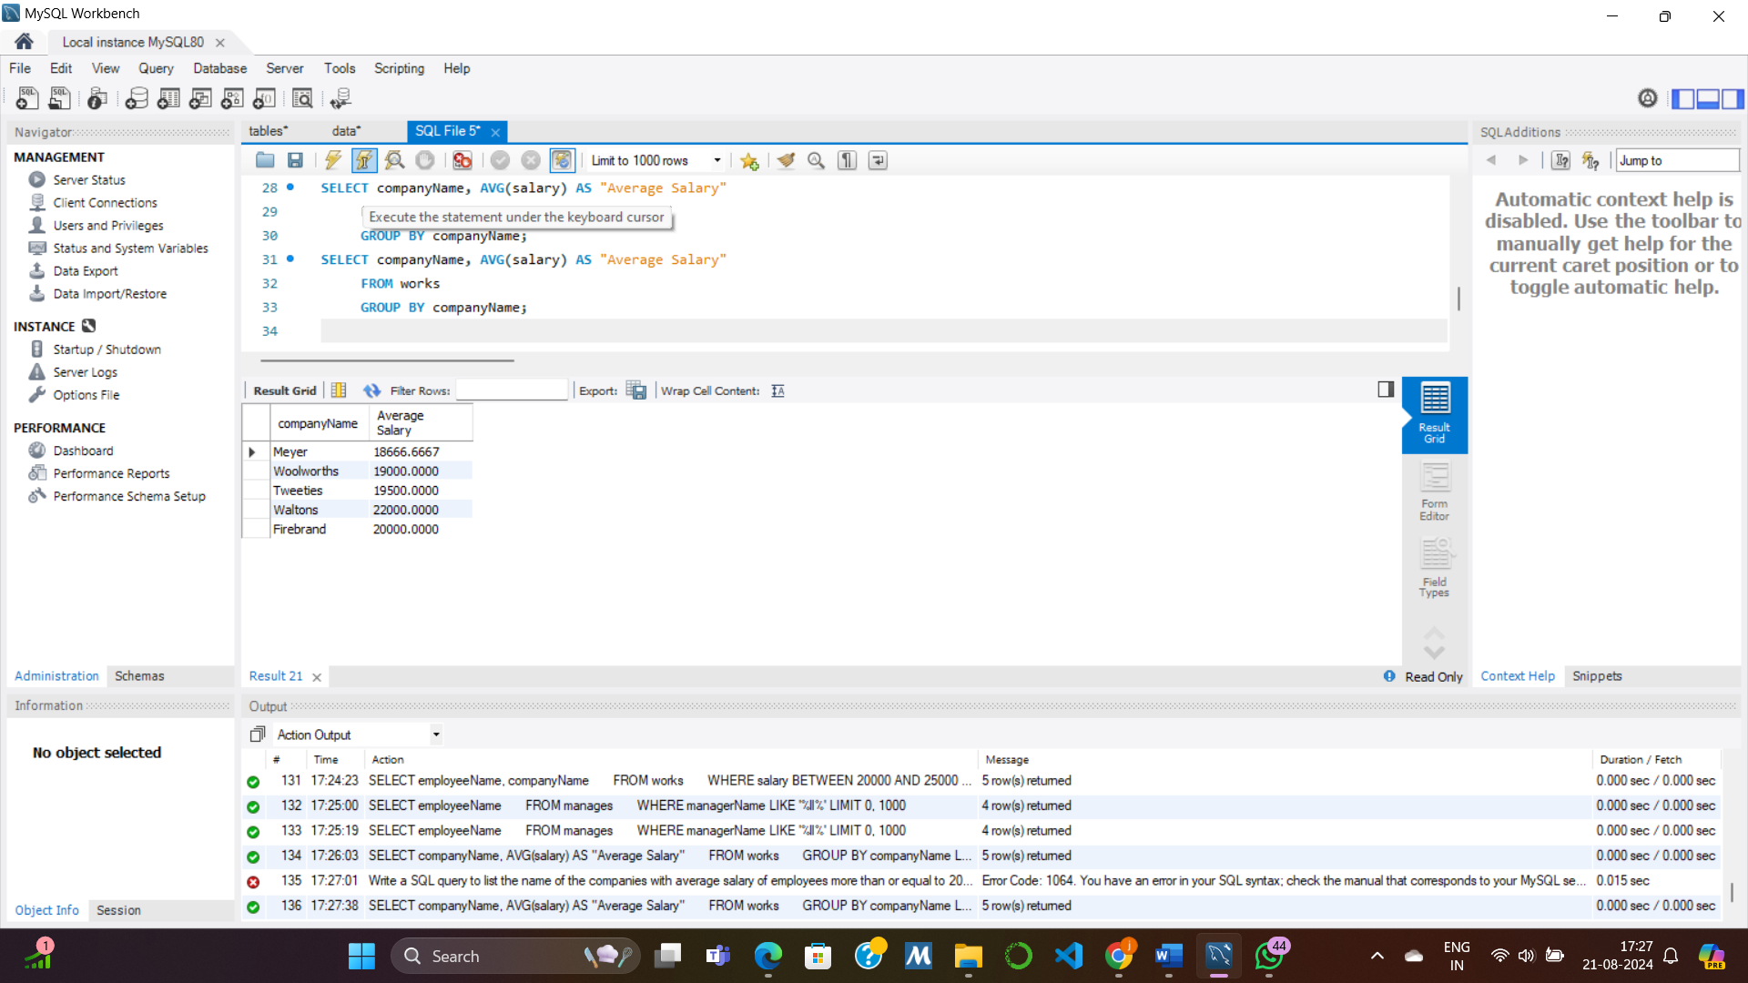

Write a SQL query to select details of the employees who works in companies located in Rye. [Relevant tables: Works and Company; Hint: use a subquery]

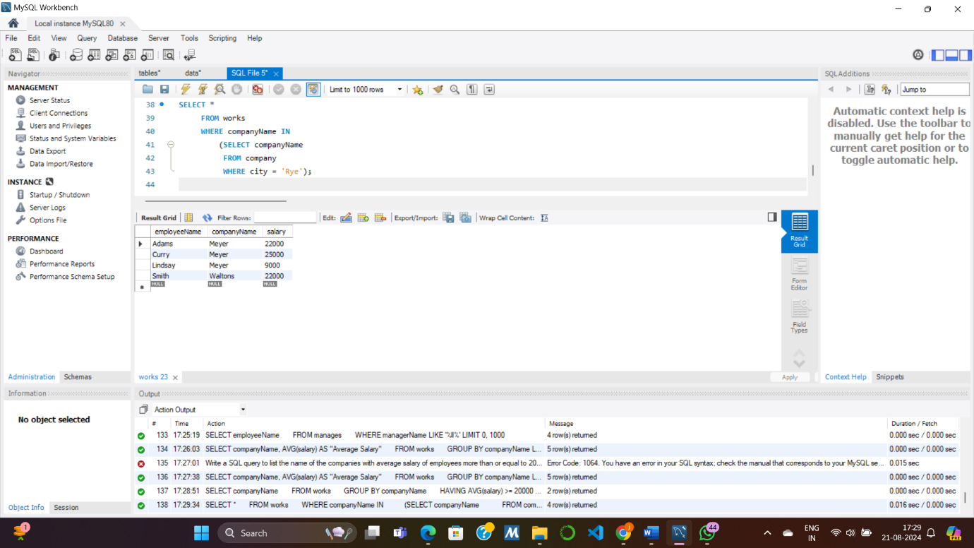

Write a SQL query find the number of rows in the Manages table. [Relevant tables: Manages; Hint: use COUNT()]

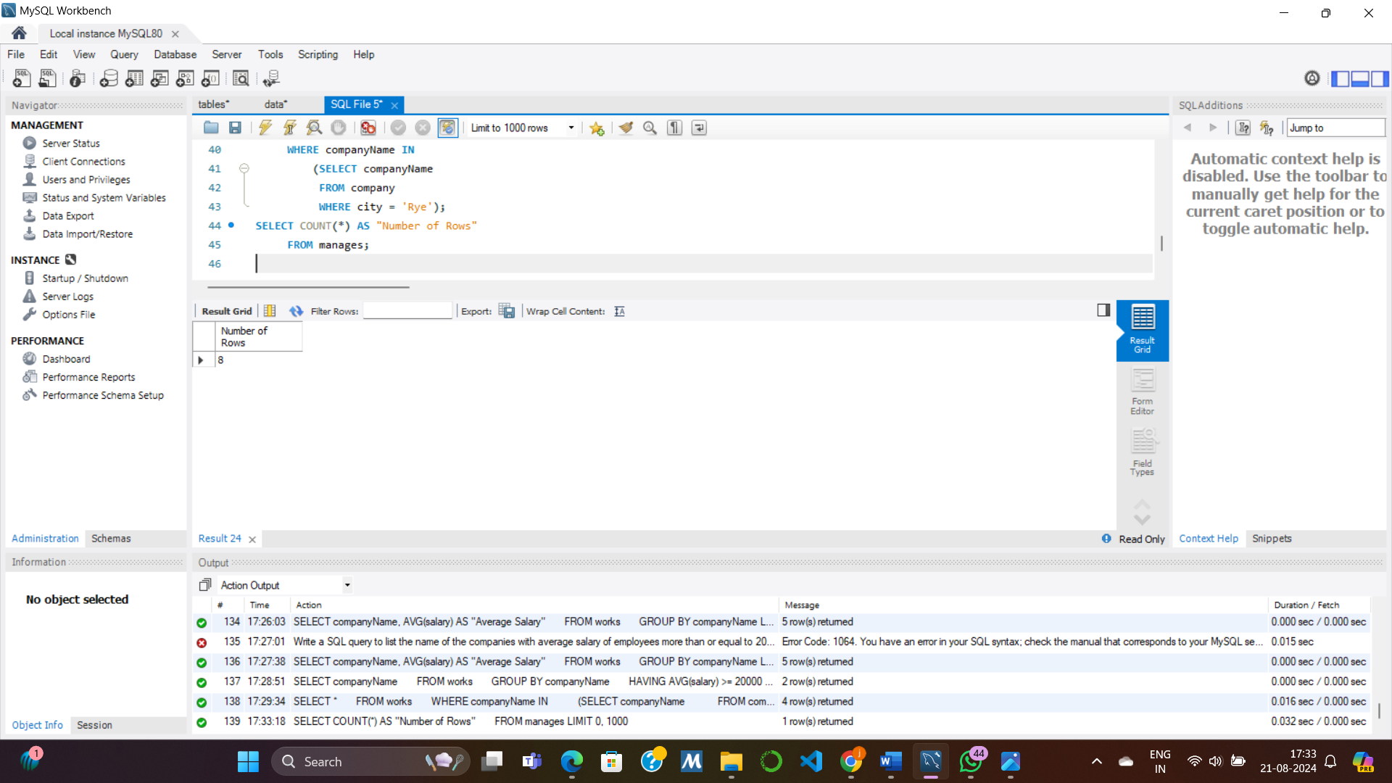

Write a SQL query to find the name and company of the employee earning the highest salary. [Relevant tables: Works; Hint: use a subquery using max() to find the highest salary.

